Chapter 7, Problem 55.

Find v(t) for t < 0 and t > 0 in the circuit in Fig. 7.121.

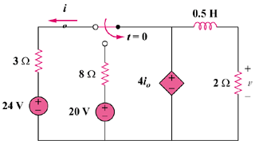

Figure 7.121
For Prob. 7.55.

